Supply Chain Management (SCM) — NPTEL
Week 10 · Session 1: Digital Infrastructure — Product Tracking & Traceability (Introduction)
1. New Module — Digital Infrastructure for Supply Chains
Course Journey So Far
✓ SC fundamentals: design, operations, procurement strategy
✓ Role of technology & decision making (optimization, analytics)
✓ SC network design, facility location, K-means, DEA
→ Digital Infrastructure for Supply Chains — starting now
→ → First topic: Product Tracking & Traceability

- Digital infrastructure is a prerequisite for modern SC functioning — not optional
- This module covers the enabling layer that makes SC technology and analytics possible

2. Why SC Complexity Makes Tracking Essential
- Real supply chains are not simple linear flows — they are complex multi-tier networks
- Interactions occur: within tiers (factory to factory) AND across tiers (factory directly to retailer)
- Product changes form as it moves: raw material → WIP → finished goods → palletized bundles

SC Node | Role & Complexity
Material Suppliers / Component Suppliers | Supply raw materials / ingredients / components (may be globally sourced)
Factories / Manufacturers | Convert inputs to finished goods. May also receive inter-factory WIP transfers
Warehouses / Distribution Centers | Intermediate storage & dispatch. Palletization/packaging may occur here
Retailers | Multiple retail points, varying sizes, serve end customers
End Customers | Consume product; their behavior drives upstream decisions
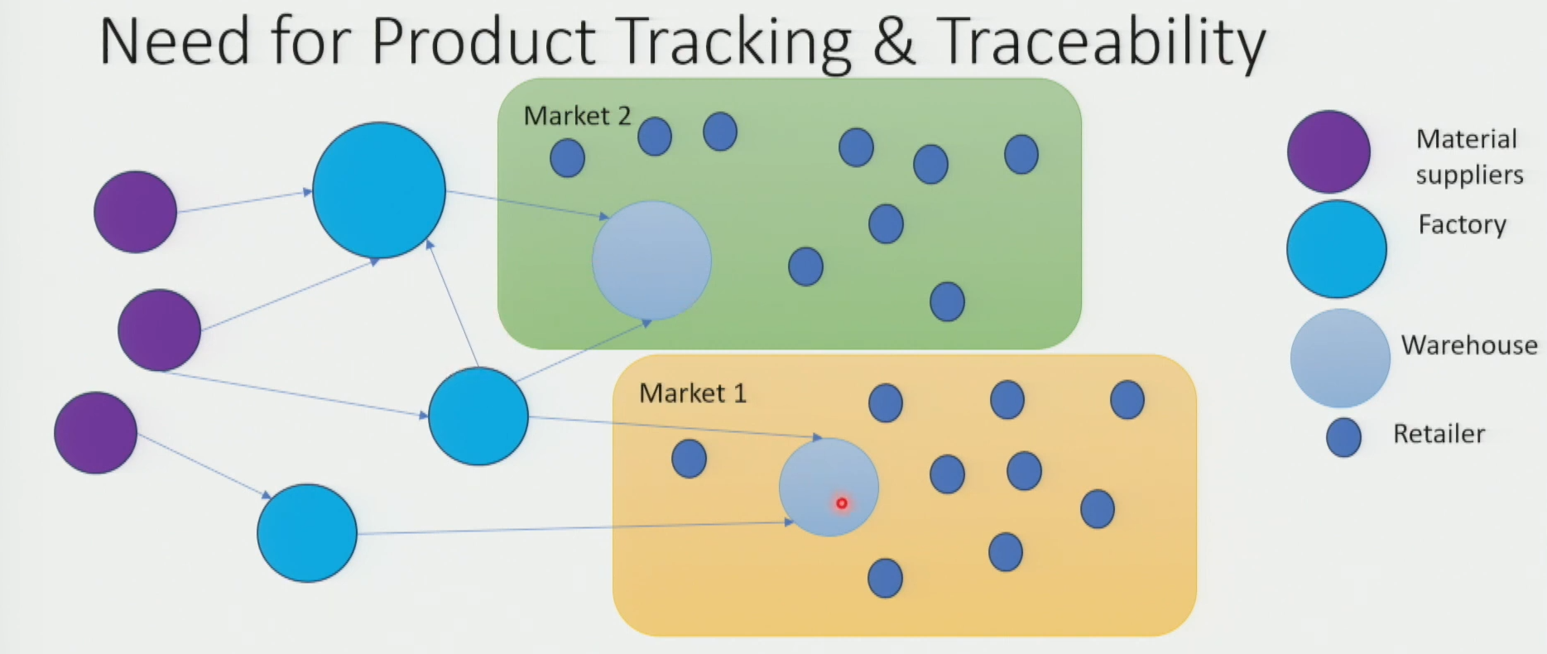
Inter-tier Complexity Examples
- One supplier may serve multiple factories (shared supplier) — creates interdependency
- Factories may transfer work-in-process (WIP) to each other — intra-SC material flow
- Factory may serve retailers directly bypassing distribution centers — channel variation
- Component sourcing may be global (e.g., China) while consumption is local (e.g., US) — geo complexity
3. Three Flows in a Supply Chain
- Tracking must cover all three flows — they are interdependent and all generate critical data

Flow Type | What it Involves | Why Tracking Matters
Material Flow | Raw materials → factories → WIP → finished goods → warehouses → retailers → customers  Product changes form at each stage (components → WIP → finished goods → pallets) | Knowing location & condition of product at every node  Enables reallocation, production planning, stock management
Financial Flow | Cash transactions at POS (customer → retailer)  Credit transactions across B2B links  Simplified if one company owns entire downstream SC | Matching payments to actual goods received  Detecting discrepancies, preventing wrongful claims
Information Flow | Purchase data, inventory levels, dispatch schedules, procurement status  Flows in both directions — upstream and downstream | Enables demand sensing, supply adjustments, service-level promises to customers  Feeds decision-making at every tier

★ Product tracking primarily enables visibility of MATERIAL FLOW, but its data feeds INFORMATION FLOW and helps verify FINANCIAL FLOW accuracy.

4. Why Product Tracking & Traceability is Needed
- Three core reasons — each drives different types of SC decisions:

1 | Product health status | Know if product is expired / damaged / in proper storage conditions. Enables FIFO / FEFO management. Prevents dead stock and quality failures.
2 | Product location & movement | Know where product currently is in the SC. Enables ETA promises to customers. Triggers production or reallocation when shortages detected.
3 | Product usage information | Know how customers use/discard product → viability signal. Know if factory is using materials efficiently → productivity insight. Reveals mishandling at logistics / warehouse tier.

Decision-Making Example (Demand Spike)
- Sudden demand spike detected at retail points in Market 1 → shortage indicators appear
- Tracking enables two decision options:
- Option A: Reallocate finished goods stock from Market 2's warehouse to Market 1
- Option B: Prioritize production and dispatch from factory to Market 1 directly
- Without tracking: neither option can be evaluated — you don't know what stock exists where

5. Challenges When Product Tracking is Absent
- Poor or absent tracking creates cascading problems across the SC:

Challenge | How it Arises (Root Cause) | Impact
Bullwhip Effect | No visibility of actual downstream inventory  Manufacturer assumes worst case → orders excess raw materials  Suppliers receive amplified orders → cascade upstream  Phantom / erroneous orders inflate the entire supply chain | Excess inventory build-up, cost spikes, demand distortion
Poor Materials Management | Cannot track inventory age or expiry  FIFO / FEFO disciplines break down  Old / expired stock stays in system while fresh stock arrives | Dead stock, expired products, poor quality at customer end
Counterfeit / Fake Products | No traceability of genuine product flow  Look-alike products enter SC under original brand name  Especially critical: pharma, apparel, electronics | Loss of brand value, lost revenues from secondary fake market
Theft, Pilferage & Wrongful Claims | Inventory stolen in bulk or gradually — undetected  False claims: customers present fake/stolen items for replacement  Cannot verify if damage was caused by buyer or SC player | Revenue loss, excess costs, excess inventory carrying costs, excess insurance costs, litigation expenses
Loss of Usage Information | Cannot monitor how customers use / discard product  Cannot detect mishandling by logistics / warehouse players  Cannot distinguish product design flaw vs handling flaw | Hampers market growth, strains SC relationships, poor service design

★ Most SC tracking problems create a chain reaction: poor visibility → wrong decisions → excess costs → poor service → lost revenues.

6. Bullwhip Effect — Key Concept
- Definition: amplification of actual demand fluctuations as orders move upstream through the SC
- Caused by: each tier adds buffer based on worst-case assumptions due to lack of downstream visibility
- Result: tiny demand change at retail → large order swings at manufacturer → even larger at supplier
- Product tracking directly reduces bullwhip by giving upstream players real-time demand and inventory signals

★ Bullwhip effect = amplified orders due to information gaps. Product tracking = the antidote — provides actual inventory and demand visibility.

7. Improving Product Tracking & Traceability — Three-Pronged Approach
- No single intervention is sufficient — all three must work together:

Pillar | What it Involves | Examples
1. Process | Systematic record-keeping of product movement  Quality assurance & regular inspection protocols  Structured inventory counting procedures  Decision-making processes that use tracking data | Regular cycle counts at warehouses  Incoming goods inspection logs  SOP for damaged goods handling  Inventory reorder trigger processes
2. Technology | Real-time tracking tools & devices  Decision support systems fed by tracking data  Auto-capture of product movement signals | Sensors, scanners  RFID chips, barcode, QR codes  IoT devices for storage condition monitoring  ERP / WMS systems with tracking modules
3. People | Train personnel on good handling practices  Train on maintaining accurate records  Train on using tracking data for decisions | Warehouse staff trained on FIFO/FEFO  Logistics staff trained on proper scanning  Managers trained on interpreting dashboards

- Technology alone fails without trained people to use it and processes to act on the data
- Process alone is too slow and error-prone without technology to automate capture
- Next session: deep dive into specific tools and technologies for tracking

Session Summary
- New module: Digital Infrastructure — first topic is Product Tracking & Traceability
- SC complexity: multi-tier, multi-form product flow; within-tier and cross-tier interactions; global sourcing
- Three flows: Material (physical product), Financial (payments), Information (data) — all need tracking
- Why tracking: (1) product health/condition, (2) location & movement, (3) usage information
- 5 challenges from absence: Bullwhip effect, poor materials management, counterfeits, theft/claims, loss of usage info
- Bullwhip effect: amplification of orders upstream due to lack of downstream inventory visibility
- 3-pronged improvement: Process + Technology + People — must work together

★ Exam Tip: Three reasons for product tracking: (1) health/condition of product, (2) location/movement, (3) usage information. Know all three with examples.
★ Exam Tip: Bullwhip effect = amplified orders upstream caused by information gaps. Product tracking reduces bullwhip by providing real-time visibility of actual inventory.
★ Exam Tip: Five challenges from absent tracking: bullwhip, poor materials mgmt, counterfeits, theft/pilferage/claims, loss of usage info. Each leads to cost and revenue impacts.
★ Exam Tip: Three-pronged approach to improve tracking: Process (records, QA, SOPs), Technology (RFID, barcode, IoT, sensors), People (training on handling, records, decision-making).

